**Audrey Long**

**Project 1**

**Morse Code with LED**

**02/08/2020**

**Project Description**

Project 1 Morse Code LED or LCD System Development

Project - Hello World

Develop a C or C++ (or whatever other language you prefer) application which executes on an Arduino and displays a user typed string, such as “Hello World”, as Morse Code on an LED (or several LEDs), or an LCD.

Design using a Round Robbin Design where in a loop it waits for a string, displays it in Morse Code, and only exits the loop if a sentinel is entered, such as ctrl-z

Submit per directions in “Project Submission.docx”

**Requirements**

-setup the LED into the correct pin location

-indicate what delay a dot (250 MS) represents and what a dash (500 MS) represents

- make a sentinel to indicate program completion

- make a table of case insensitive alphabet to Morse code from

- receive a string of serial input

- loop through each character in the string

- each parsed character must look up the corresponding series of dots and dashes and display on the LED

- the input must only have alphabetical characters and spaces

- after the input string is converted to a Morse string, we must index character by character to then issue the blinking LED commands

**Embedded System Design**

Below is a pictorial representation of the designed embedded system. I am using the Elegoo Uno R3 along with a yellow LED inserted into PIN 13 and GND.

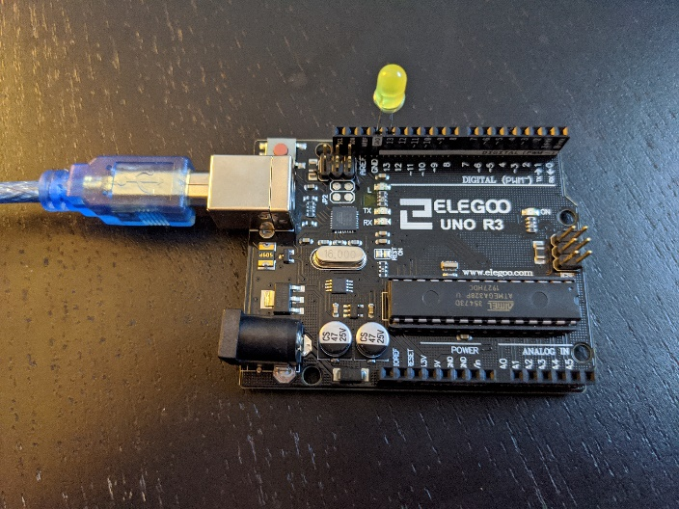

**Additional Information**

Below is a Morse code guide which gave me more insights on the correct representation of an alphabetical translation to dot and dash notation.

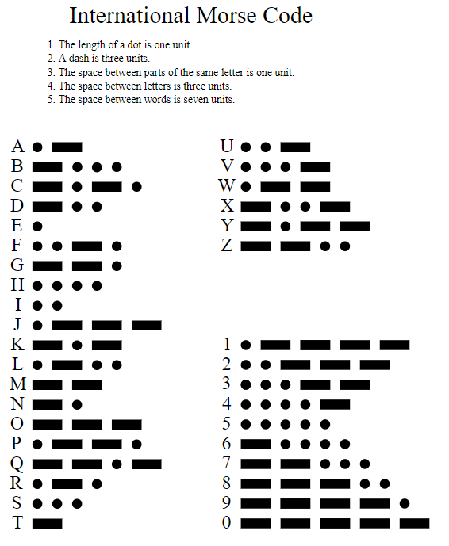

**Code Base**

Please refer to my GitHub:

<https://github.com/cheesemuffinish/Embedded_Projects/tree/master/Project1_morse_code>

**Video**

Please refer to my YouTube:

<https://www.youtube.com/watch?v=dK5PeJXIZyw>